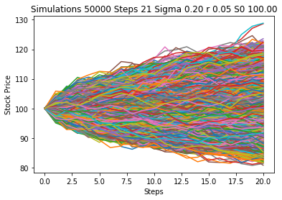

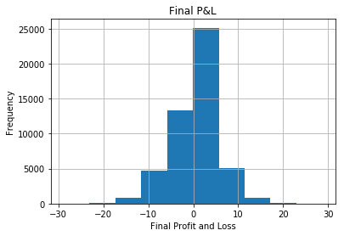

Mean of P&L

Final P&L -0.00

dtype: float64

----------------------------------------------------------------------

Standard Deviation of P&L

Final P&L 5.01

dtype: float64

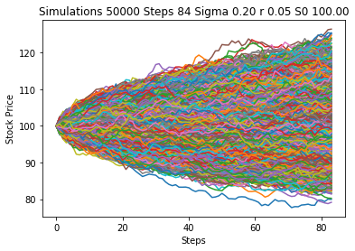

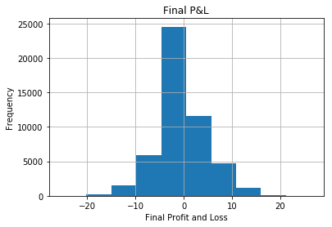

Mean of P&L

Final P&L 0.00

dtype: float64

----------------------------------------------------------------------

Standard Deviation of P&L

Final P&L 5.11

dtype: float64